CSA1715-ARTIFICIAL INTELLIGENCE
LAB PROGRAMS
14-07-2026
2.Write the python program to solve 8-Queen problem.

Aim
To write a Python program to solve the 8-Queen Problem using the Backtracking algorithm.

Algorithm
- Initialize an 8×8 chessboard representation using a list.
- Start placing queens row by row from the first row.
- For each row, check every column to find a safe position.
- A position is considered safe if no previously placed queen is in the same column or diagonal.
- If a safe position is found, place the queen and recursively move to the next row.
- If no safe position exists in the current row, backtrack by removing the previously placed queen and try the next possible position.
- Repeat the process until all eight queens are placed successfully.
- Display the final chessboard with the positions of all queens.

Program
n=8
b=[-1]*n
def safe(r,c):
for i in range(r):
if b[i]==c or abs(b[i]-c)==abs(r-i):
return False
return True

def solve(r):
if r==n:
for i in range(n):
for j in range(n):
if b[i]==j:
print("Q",end=" ")
else:
print(".",end=" ")
print()
return True
for c in range(n):
if safe(r,c):
b[r]=c
if solve(r+1):
return True
return False

solve(0)

Output
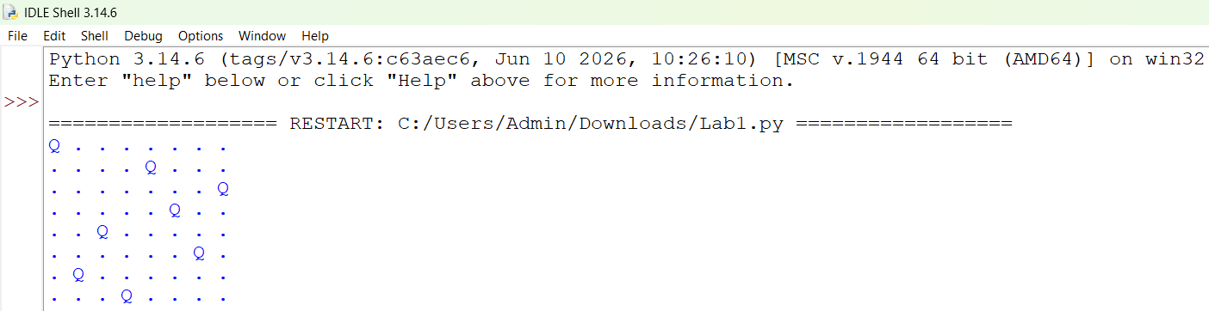

Result
Thus, the Python program to solve the 8-Queen Problem using the Backtracking algorithm was executed successfully.

